**Competition Brief**

**Competition Title**

Graphic Design

**Competition Overview**

## Graphic designers have specialist skills to design and handle images and text across a wide range of contexts from print to digital and UX design, posters to motion graphics and animation.

## 

## In this competition, competitors have to develop and demonstrate a variety of creative and technical skills that are essential within the contemporary graphic communication and creative industries.

## 

## **Entry Criteria**

## The competition is for those training for a career in Graphic Design and studying on vocational courses up to Level 3.

## Please ensure that your entrants have the skills and competences to complete the task.

**Entry capacity restrictions by organisation**

Maximum of up to 3 entries per organisation.

This is the maximum number of entries permitted by an organisation for this competition.

This is determined by ‘location’ and ‘organisation’. ‘Organisation’ refers to the competitors training provider/employer. ‘Location’ refers to a site where the competitor studies / is employed. For further guidance on these capacities, click [here](https://www.skillscompetitionwales.ac.uk/terms/entry-capacity-restrictions-by-organisation)

**Brief**

**Passive Brief** 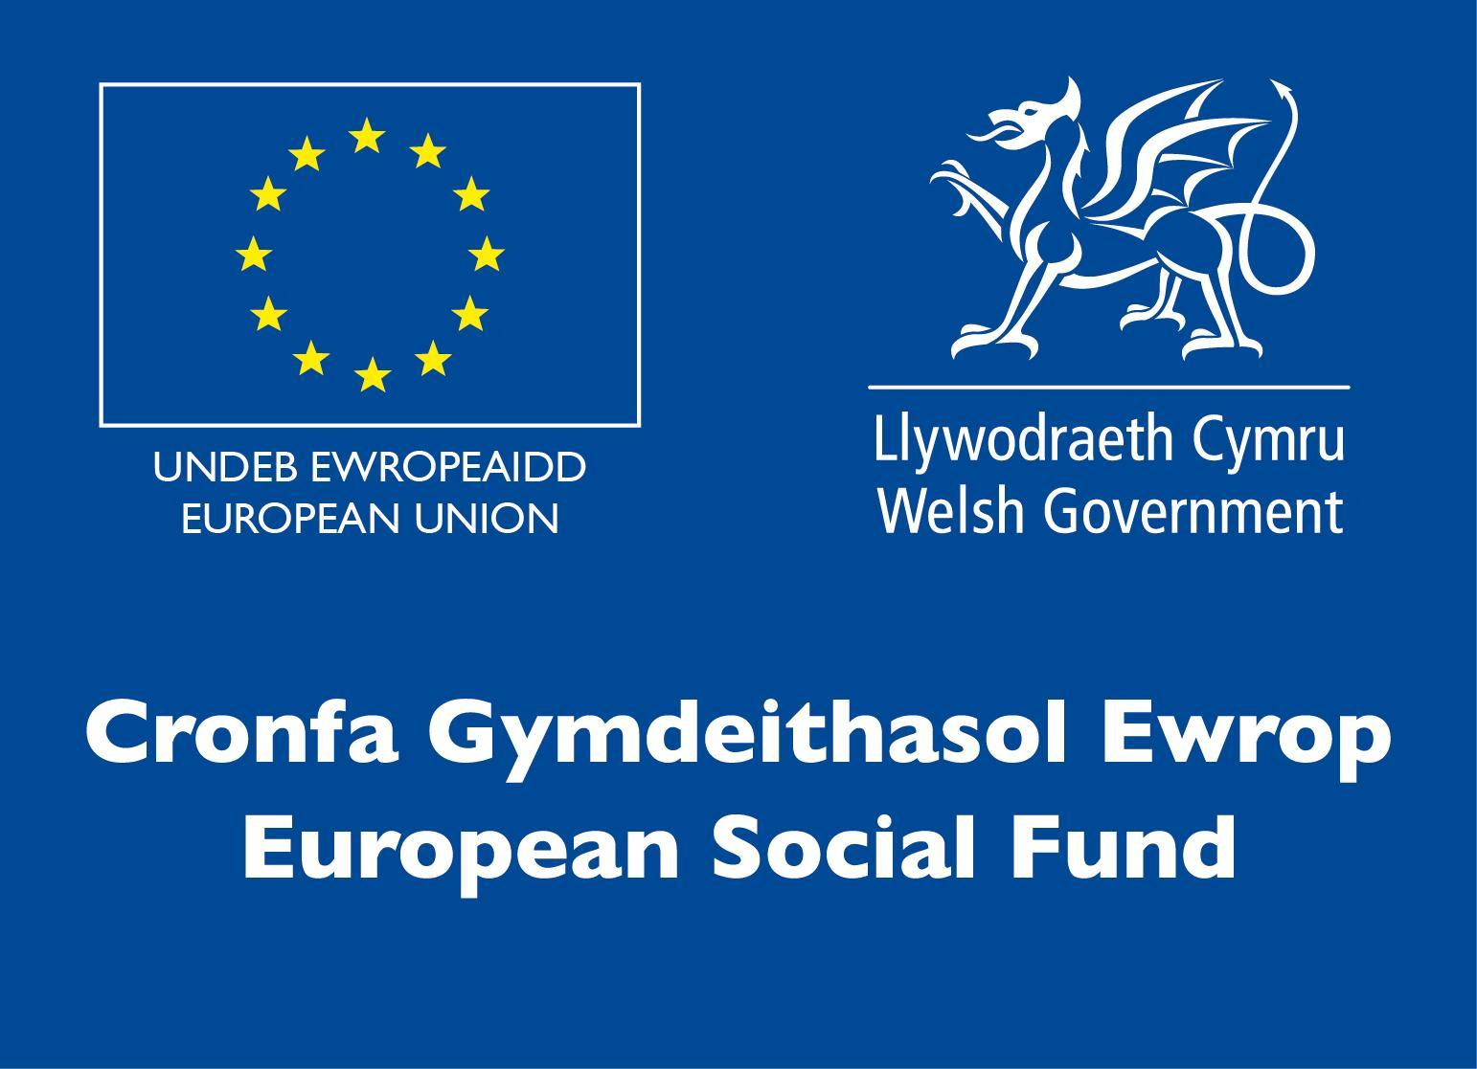

Below are three companies who are looking for an exciting and unique rebrand. Please note these companies currently do not exist; they have been made up for the purpose of the competition.

| **Company Name** | **Details about the company** |
| --- | --- |
| ***The Virtual Reality Museum***  Virtual online museum of arts and culture. | This museum celebrates all things arts and culture in a virtual space. This included online exhibitions of art work and virtual tours of physical galleries. The museum has an events program which includes, artists talks, open competitions, virtual artists studio tours and workshops. In order to support artists they host a bi-montly art auction consisting of students' work, physical and digital art alongside professional artists.  This campaign is to launch the museum and its events program.  *Audience*: Art students, artists, art collector: an audience interested in art. |
| ***SpaceM***  Flights currently leaving from a new airport in the midlands. | This is the first company to make passenger flights to Mars. Rocket powered, the journey is not for the faint hearted, but upon arrival on Mars, passengers will be able to meander the landscape and feel zero gravity.  Journey time to Mars 5 hours; on land for 5 hours and back to earth will take 4 hours. Total trip 14 hours.  This is cheap space travel and the first company to hit the market offering space travel to everyone.  *Audience*: 18 - 40 year olds wanting to experience space |
| ***Popty***  Located in the foothills of Snowdonia. | Welsh bakery company serving delicious homemade bread, cakes, welsh cakes and bara brith. Most famous for the freshly baked Welsh Cakes that often sell out before 10am. They have a secret ingredient which makes them so moreish, people travel from all over Wales to have some.  This is a small independent family run business, selling from their shop at the foothills of Snowdonia. They also have an online shop which they are looking to expand further outside of Wales.  *Audience:* Wanting to expand into an online selling market for their welsh cakes, audience 40+ year olds. Locals who enjoy cakes and tourists wanting the taste of Wales. |

Choose **one** of the above companies to create a strong, unique and modern brand image for the business.

Create an appropriate logo for the business which can be used on their website, social media and used to advertise the company. Please submit designs for a logo and icon for Instagram, Facebook and a Facebook cover image.

*Consider how the logo has the potential to be used for animation and interaction. Supporting materials to demonstrate applications across different platforms or applications.*

**Deadline:** 14th December, 2021

**Submit**: Supporting materials, logo, instagram icon, facebook icon and facebook cover image. Plus any animations you have created (not essential).

Please send **ALL** of your original photoshop files along with exported jpegs.

**Share via Google Drive to:** amber.sheppard[@colegsirgar.ac.uk](mailto:olivia.clemence@colegsirgar.ac.uk)

This will be using the below marking criteria:

| **Criterion ID** | **Description** | **Max. Marks** |
| --- | --- | --- |
| **A** | Idea Generation  *(design and idea development, evaluation of visual responses to communication problems, appropriateness of ideas and originality)* | 16 |
| **B** | Communication and Interpersonal Skills  *(follow the brief and show visual development through sketches and digital concepting)* | 10 |
| **D** | Design Outcomes  *(How well the design solves the problem, clear and appropriate style of design and the artwork itself)* | 15 |
| **E** | Technical Aspects and Output  *(create, manipulate and optimize images, use of colour, saving of files correctly and use of software)* | 17 |
|  | **Total Marks** | **58** |

You will know if you have got through to the final by 5pm friday 17th December, 2021.

**Competition Day / Live Heat**

The Skills Competitions Wales, Graphic Design, will be held between 17th January and 4th February 2022, location tbc.

All competitors will have the use of an individual iMac with the Adobe Creative Suite and access to the internet. Wacom Graphics Tablets will also be available. All competitors will have access to pens, paper, drawing materials and a printer.

**Competition Rules**

* Use only the materials supplied in the Digital Media Pack.
* Competitors must work independently (without support from other students/tutors)
* Refrain from including offensive, sexual, political, controversial or inflammatory text or images.
* Mobile phones are to be switched off during competition activity.
* Listening to music via headphones is permitted during competition activity.
* Any questions during competition activity should be addressed to the competition judging panel.
* Competitors should not communicate with other competitors during competition activity.
* It is the responsibility of each competitor to arrive on time for each competition session. No additional time will be allowed if you arrive late.
* Technical failure of your equipment should be reported immediately to the judging panel. Additional time will be allocated if the fault is beyond the control of the competitor.
* Competitors are solely responsible for the saving of their own files, especially in the unfortunate event of a computer malfunction. Instructions will be given as to where the files need to be saved.
* Competitors are not allowed to use any materials other than that supplied for the set project by the event Competition Supervisor. No prepared work will be allowed in the competition.

For full terms and conditions of entry and competition rules visit [www.inspiringskills.gov.wales/terms-and-conditions](http://www.skillscompetitionwales.ac.uk/terms-and-conditions)

**Marking and Assessment**

Marking and judging of this competition will be done by a team of experts from Industry, Further Education or Training Provider, using a marking criteria and allocated marks to ensure consistency.

The marking criteria of the competition will reflect the relative significance of particular design form within the workflow, paying particular attention to the following areas.

| **Criterion ID** | **Description** | **Max. Marks** |
| --- | --- | --- |
| **A** | Work organisation and management | 10 |
| **B** | Communication and Interpersonal Skills | 10 |
| **C** | Problem Solving | 10 |
| **D** | Innovation, Creativity and Design | 50 |
| **E** | Technical Aspects & Output | 20 |
|  | Total Marks | 100 |

**Feedback and Recognition**

Individual and Group verbal feedback will be provided at the end of the competition.

No results or awards will be awarded on the day as marking will be quality assured.

All competitors will be issued with a Participation Certificate and invited to an online Celebration Event which will be held Thursday 17th March 2022, where the First, Second and Third Awards will be announced. Further details will be communicated to competitors and their points of contacts by email.

Marksheets will be made available to competitors after the quality assurance process has been completed.

**Competition Lead**

Amber Sheppard   
[amber.sheppard@colegsirgar.ac.uk](mailto:amber.sheppard@colegsirgar.ac.uk)

**Briff y Gystadleuaeth**

**Teitl y Gystadleuaeth**

Dylunio Graffig

**Trosolwg o’r Gystadleuaeth**

## Yn y gystadleuaeth hon, mae'n rhaid i gystadleuwyr ddatblygu a dangos amrywiaeth o sgiliau creadigol a thechnegol sy'n hanfodol yn y diwydiannau cyfathrebu graffig a chreadigol cyfoes.

Mae gan ddylunwyr graffig sgiliau arbenigol i ddylunio a thrafod delweddau a thestun ar draws ystod eang o gyd-destunau o brint i ddylunio digidol ac UX, posteri i graffeg symud ac animeiddio.

**Meini Prawf Ymgeisio**

Mae'r gystadleuaeth hon ar gyfer y rhai sy'n hyfforddi ar gyfer gyrfa mewn Dylunio Graffig ac yn astudio ar gwrs galwedigaethol hyd at Lefel 3.

Sicrhewch fod gan eich ymgeiswyr y sgiliau a'r cymwyseddau i gyflawni'r dasg.

**Cyfyngiadau capasiti mynediad yn ôl sefydliad**

Uchafswm o hyd at 3 ymgais i bob sefydliad.

Dyma'r nifer uchaf o gynigion a ganiateir gan sefydliad ar gyfer y gystadleuaeth hon.

Mae hyn yn cael ei bennu gan ‘leoliad’ a ‘sefydliad’. Mae ‘sefydliad’ yn cyfeirio at ddarparwr hyfforddiant/cyflogwr y cystadleuwyr. Mae ‘lleoliad’ yn cyfeirio at safle lle mae’r cystadleuydd yn astudio / yn cael ei gyflogi. I gael arweiniad pellach ar y galluoedd hyn, cliciwch [yma](https://www.skillscompetitionwales.ac.uk/terms/entry-capacity-restrictions-by-organisation)

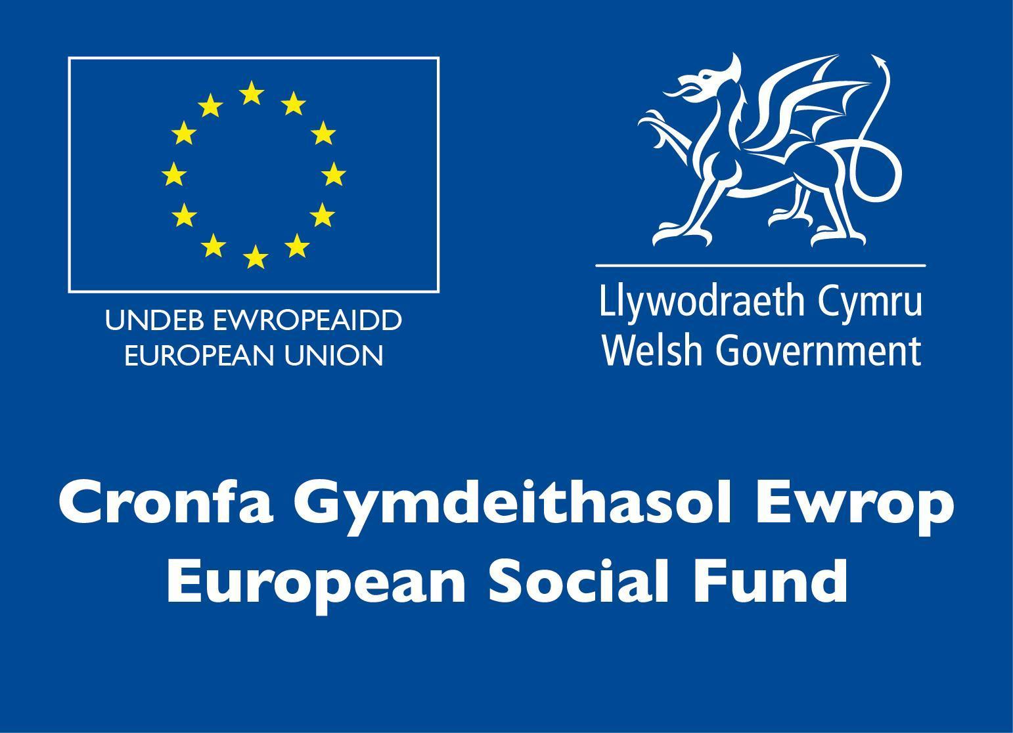

**Briff**

**Briff Goddefol**

Isod mae tri chwmni sy'n chwilio am ail-frandio cyffrous ac unigryw. Sylwch nad yw'r cwmnïau hyn yn bodoli ar hyn o bryd; maen nhw wedi cael eu dyfeisio at bwrpas y gystadleuaeth.

| **Enw’r Cwmni** | **Manylion am y cwmni** |
| --- | --- |
| ***Yr Amgueddfa Realiti Rhithiol***  Amgueddfa gelf a diwylliant rithwir ar-lein. | Mae'r amgueddfa hon yn dathlu celf a diwylliant mewn gofod rhithwir. Mae hyn yn cynnwys arddangosfeydd ar-lein o waith celf a theithiau rhithwir o orielau corfforol. Mae gan yr amgueddfa raglen ddigwyddiadau sy'n cynnwys, sgyrsiau gan artistiaid, cystadlaethau agored, teithiau stiwdio rhithwir gan artistiaid a gweithdai. Er mwyn cefnogi artistiaid maen nhw’n cynnal ocsiwn celf bob dau fis sy'n cynnwys gwaith myfyrwyr, celf gorfforol a digidol ochr yn ochr ag artistiaid proffesiynol.  Cynhelir yr ymgyrch hon i lansio'r amgueddfa a'i rhaglen ddigwyddiadau.  *Cynulleidfa*: Myfyrwyr celf, artistiaid, casglwyr celf: cynulleidfa sydd â diddordeb mewn celf. |
| ***SpaceM***  Hediadau’n gadael o faes awyr newydd yng Nghanolbarth Lloegr | Dyma'r cwmni cyntaf i fynd â theithwyr i'r blaned Mawrth. Wedi'i phweru gan roced, nid yw'r daith ar gyfer y gwangalon, ond ar ôl cyrraedd y blaned Mawrth, bydd teithwyr yn gallu crwydro’r dirwedd a theimlo dim disgyrchiant.  Amser taith i'r blaned Mawrth: 5 awr; ar y tir am 5 awr, bydd y daith yn ôl i'r ddaear yn cymryd 4 awr. Cyfanswm y daith: 14 awr.  Teithio’n rhad i’r gofod yw hyn a dyma’r cwmni cyntaf i gynnig teithio i'r gofod i bawb.  *Cynulleidfa*: Pobl ifanc 18 - 40 oed sydd eisiau profi’r gofod |
| ***Popty***  Yng ngodre Eryri. | Cwmni pobi Cymreig sy’n gweini bara cartref, cacennau, pice ar y maen a bara brith blasus. Mae’n fwyaf enwog am y pice ar y maen sy’n cael eu pobi'n ffres ac sy'n aml yn gwerthu allan cyn 10am. Mae ganddyn nhw gynhwysyn cyfrinachol sy'n eu gwneud nhw mor felys-moes-mwy, mae pobl yn teithio o bob rhan o Gymru i gael rhai.  Busnes bach annibynnol teuluol yw hwn, sy'n gwerthu o'u siop yng ngodre Eryri. Mae ganddyn nhw hefyd siop ar-lein y maen nhw am ei hehangu ymhellach y tu allan i Gymru. *Cynulleidfa*: Maen nhw eisiau ehangu i farchnad werthu ar-lein ar gyfer eu pice ar y maen, cynulleidfa 40+ oed. Pobl leol sy'n mwynhau cacennau a thwristiaid sydd eisiau blas o Gymru. |

Dewiswch **un** o'r cwmnïau uchod i greu delwedd brand gref, unigryw a modern ar gyfer y busnes.

Crëwch logo priodol ar gyfer y busnes y gellir ei ddefnyddio ar eu gwefan, cyfryngau cymdeithasol a'i ddefnyddio i hysbysebu'r cwmni. Cyflwynwch ddyluniadau ar gyfer logo ac eicon ar gyfer Instagram, Facebook a delwedd clawr Facebook.

*Ystyriwch sut mae gan y logo y potensial i gael ei ddefnyddio ar gyfer animeiddio a rhyngweithio. Deunyddiau ategol i arddangos rhaglenni ar draws gwahanol lwyfannau neu raglenni.*

**Dyddiad cau**: 14 Rhagfyr, 2021

**Cyflwyno**: Deunyddiau ategol, logo, eicon Instagram, eicon Facebook a delwedd clawr Facebook. Ynghyd ag unrhyw animeiddiadau rydych chi wedi'u creu (ddim yn hanfodol).

Anfonwch **BOB UN** o'ch ffeiliau photoshop gwreiddiol ynghyd â jpegs wedi'u hallgludo.

**Rhannwch trwy Google Drive i**: [amber.sheppard@colegsirgar.ac.uk](mailto:amber.sheppard@colegsirgar.ac.uk)

Bydd hyn yn defnyddio'r meini prawf marcio isod:

| **Cyfeirnod Maen Prawf** | **Disgrifiad** | **Uchafswm Marciau** |
| --- | --- | --- |
| **A** | Cynhyrchu Syniadau  *(datblygu dyluniad a syniad, gwerthuso ymatebion gweledol i broblemau cyfathrebu, priodoldeb syniadau a gwreiddioldeb)* | 16 |
| **B** | Sgiliau Cyfathrebu a Rhyngbersonol  *(dilynwch y briff a dangos datblygiad gweledol gyda brasluniau a chysyniad digidol)* | 10 |
| **D** | Deilliannau’r Dyluniad  *(Pa mor dda mae'r dyluniad yn datrys y broblem, arddull glir a phriodol y dyluniad a'r gwaith celf ei hun)* | 15 |
| **E** | Agweddau Technegol ac Allbwn  *(creu, trin a gwneud y gorau o ddelweddau, defnyddio lliw, arbed ffeiliau’n gywir a defnyddio meddalwedd)* | 17 |
|  | **Cyfanswm Marciau** | **58** |

Byddwch yn gwybod a ydych wedi cyrraedd y rownd derfynol erbyn 5pm dydd Gwener 17 Rhagfyr, 2021.

**Diwrnod y Gystadleuaeth / Rownd Fyw**

Cynhelir Cystadleuaeth Sgiliau Cymru, Dylunio Graffig, rhwng 17 Ionawr a 4 Chwefror 2022, lleoliad i’w gadarnhau.

Bydd pob cystadleuydd yn cael defnyddio iMac unigol gyda'r Adobe Creative Suite a mynediad i'r rhyngrwyd. Bydd e-lechi graffeg Wacom hefyd ar gael. Bydd gan bob cystadleuydd fynediad at beniau, papur, deunyddiau tynnu llun ac argraffydd.

**Rheolau’r Gystadleuaeth**

• Defnyddiwch y deunyddiau a gyflenwir yn y Pecyn Cyfryngau Digidol yn unig.

• Rhaid i gystadleuwyr weithio'n annibynnol (heb gefnogaeth myfyrwyr / tiwtoriaid eraill)

• Peidiwch â chynnwys testun neu ddelweddau tramgwyddus, rhywiol, gwleidyddol, dadleuol neu ymfflamychol.

• Bydd ffonau symudol yn cael eu diffodd yn ystod y cystadlu.

• Caniateir gwrando ar gerddoriaeth trwy glustffonau yn ystod y cystadlu.

• Dylid cyfeirio unrhyw gwestiynau yn ystod y cystadlu at banel beirniaid y gystadleuaeth.

• Ni ddylai cystadleuwyr gyfathrebu â chystadleuwyr eraill yn ystod y cystadlu.

• Cyfrifoldeb pob cystadleuydd yw cyrraedd mewn pryd ar gyfer pob sesiwn gystadlu. Ni chaniateir unrhyw amser ychwanegol os byddwch chi'n cyrraedd yn hwyr.

• Dylid rhoi gwybod i'r panel beirniaid am fethiant technegol eich offer ar unwaith. Rhoddir amser ychwanegol os yw'r nam y tu hwnt i reolaeth y cystadleuydd.

• Ni fydd mynediad i'r Rhyngrwyd ar gael trwy gydol y gystadleuaeth.

• Mae cystadleuwyr yn llwyr gyfrifol am arbed eu ffeiliau eu hunain, yn enwedig os bydd cyfrifiadur yn anffodus yn camweithio. Rhoddir cyfarwyddiadau ynghylch ble mae angen cadw'r ffeiliau.

• Rhaid i'r cystadleuwyr beidio â gweithio, cyffwrdd â'r cyfrifiadur nac unrhyw ddeunydd arall sy'n gysylltiedig â'r gystadleuaeth cyn y signal cychwyn, a rhaid iddyn nhw roi'r gorau i weithio a pheidio â chyffwrdd â'r cyfrifiadur nac unrhyw ddeunyddiau eraill sy'n gysylltiedig â'r gystadleuaeth ar ôl y signal stopio. Mae hyn hefyd yn wir am y signalau egwyl ginio.

• Ni chaniateir i gystadleuwyr ddefnyddio unrhyw ddeunyddiau heblaw'r deunyddiau a gyflenwir ar gyfer y prosiect penodol gan Oruchwyliwr Cystadleuaeth y digwyddiad. Ni chaniateir unrhyw waith wedi’i baratoi yn y gystadleuaeth.

I gael y telerau ac amodau ymgeisio llawn a’r rheolau cystadlu, ewch i [www.inspiringskills.gov.wales/terms-and-conditions](http://www.skillscompetitionwales.ac.uk/terms-and-conditions)

**Marcio ac Asesu**

Bydd marcio a beirniadu'r gystadleuaeth hon yn cael ei wneud gan dîm o arbenigwyr o'r Diwydiant, Addysg Bellach neu Ddarparwr Hyfforddiant, gan ddefnyddio meini prawf marcio a marciau a ddyrennir i sicrhau cysondeb.

Bydd meini prawf marcio'r gystadleuaeth yn adlewyrchu arwyddocâd cymharol ffurf ddylunio benodol yn y llif gwaith, gan roi sylw arbennig i'r meysydd canlynol.

| **Cyfeirnod y Maen Prawf** | **Disgrifiad** | **Uchafswm Marciau** |
| --- | --- | --- |
| **A** | Trefnu a rheoli gwaith | 10 |
| **B** | Cyfathrebu a Sgiliau Rhyngbersonol | 10 |
| **C** | Datrys Problemau | 10 |
| **D** | Arloesedd, Creadigrwydd a Dylunio | 50 |
| **E** | Agweddau ac Allbwn Technegol | 20 |
|  | Cyfanswm Marciau | 100 |

**Adborth a Chydnabyddiaeth**

Bydd adborth llafar i Unigolion a Grwpiau yn cael ei roi ar ddiwedd y gystadleuaeth.

Ni fydd unrhyw ganlyniadau na dyfarniadau yn cael eu dyfarnu ar y diwrnod gan y bydd ansawdd y marcio yn cael ei sicrhau.

Bydd pob cystadleuydd yn cael Tystysgrif Cyfranogi ac yn cael ei wahodd i Ddigwyddiad Dathlu ar-lein a gynhelir Dydd Iau 17eg Mawrth 2022, lle bydd y Gwobrau Cyntaf, Ail a Thrydedd yn cael eu cyhoeddi. Bydd manylion pellach yn cael eu cyfleu i gystadleuwyr a'u pwyntiau cyswllt trwy e-bost.

Bydd taflenni marcio ar gael i gystadleuwyr ar ôl i'r broses sicrhau ansawdd gael ei chwblhau.

**Arweinydd y Gystadleuaeth**

  
[amber.sheppard@colegsirgar.ac.uk](mailto:amber.sheppard@colegsirgar.ac.uk)