**Competition Brief**

**Competition Title**

Health and Social Care

**Competition Overview**

Health and Social Care workers provide quality care to individuals in a range of facilities, such as a nursery, residential home, hospital, or other caring establishment. The nature of their work requires them to have knowledge and skills covering elements of sociology, biology, nutrition, law, and ethics.

In this competition, competitors will be expected to exercise judgement and take appropriate action to support individuals to maintain their independence, dignity and control through a variety of practical exercises.

**Entry Criteria**

The competition is for those training for a career in Health & Social Care and studying a Level 3 qualification.

## Please ensure your entrants have the skills and competencies to complete the task.

## Date - Between 25th January and 5th February.

## You will be allocated a date and instructions to upload your video recording once registration has closed.

## Entry capacity restrictions by organisation

Maximum of up to 2 per location.

This is the maximum number of entries permitted by an organisation for this competition.

This is determined by ‘location’ and ‘organisation’. ‘Organisation’ refers to the competitors’ training provider/employer. ‘Location’ refers to a site where the competitor studies / is employed. For further guidance on these capacities, click [here](https://www.skillscompetitionwales.ac.uk/terms/entry-capacity-restrictions-by-organisation)

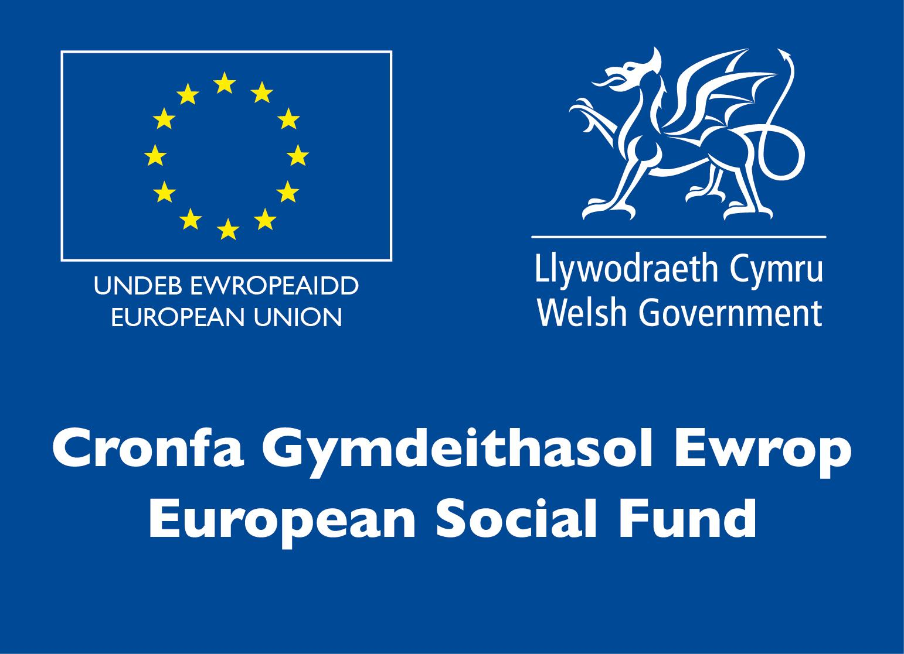**Brief**

The competition consists of three activities.

**Activity 1: Individual task: up to 10 minutes**

You are a health care worker and your manager has asked to deliver a 10 minute presentation to the other care workers in the organisation. You will need to address the following: How has the Covid 19 epidemic impacted the Care Sector? This will need to be recorded.

**Activity 2: Individual task: up to 15 minutes**

You have been asked to make a video demonstrating the correct procedure for washing your hands.

**Activity 3: Multiple choice questionnaire: up to 15 minutes**

A multiple choice questionnaire for the entrants to complete online in the form of a Kahoot.

**Infrastructure List**

Resources, equipment available at the venue.

**Competition Rules**

For full terms and conditions of entry and competition rules visit [www.skillscompetitionwales.ac.uk/terms-and-conditions](http://www.skillscompetitionwales.ac.uk/terms-and-conditions)

**Competition specific rules**

Those wishing to enter this competition should be:

• Dress should be professional and adhere to relevant professional standards. Attire must be non-branded (i.e. no college/employer logos visible).

• All activities must be completed by competitors within the allotted time.

**Generic competition rules**

• Mobile phones are to be switched off during competition activity.

• Listening to music via headphones is not permitted during competition activity.

• Any questions during competition activity should be addressed to the competition judging panel.

• Competitors should not communicate with other competitors during competition activity.

• It is the responsibility of each competitor to arrive on time for each competition session. No additional time will be allowed if you arrive late.

• Technical failure of your equipment should be reported immediately to the judging panel. Additional time will be allocated if the fault is beyond the control of the competitor.

**Marking and Assessment**

Marking and judging of this competition will be done by a team of experts from Industry, Further Education or Training Provider, using a marking criteria and allocated marks to ensure consistency.

**Feedback and Recognition**

Individual and Group verbal feedback will be provided at the end of the competition.

No results or awards will be awarded on the day, as marking will be quality assured.

Certificates of Participation will be issued on the day.

Medallists will be invited to a Celebration Event which will be held in March 2021, where the First, Second and Third Awards will be presented.

Marksheets will be made available to unsuccessful competitors after the quality assurance process has been completed. Further details will be provided to all competitors upon notification of outcomes.

**Competition Lead**

**Subject Expert**

Amy Williams

[amy.williams@colegsirgar.ac.uk](mailto:amy.williams@colegsirgar.ac.uk)

**Briff y Gystadleuaeth**

**Teitl y Gystadleuaeth**

Iechyd a Gofal Cymdeithasol

**Trosolwg o’r Gystadleuaeth**

Mae gweithwyr Iechyd a Gofal Cymdeithasol yn darparu gofal o safon i unigolion mewn amrywiaeth o gyfleusterau, fel meithrinfa, cartref preswyl, ysbyty, neu sefydliad gofalu arall. Mae natur eu gwaith yn gofyn iddyn nhw feddu ar wybodaeth a sgiliau sy'n cwmpasu elfennau o gymdeithaseg, bioleg, maeth, y gyfraith, a moeseg.

Yn y gystadleuaeth hon, bydd disgwyl i’r cystadleuwyr ddefnyddio crebwyll a chymryd camau gweithredol priodol i roi cymorth i unigolion gadw eu hannibyniaeth, urddas a rheolaeth mewn amrywiaeth o ymarferion ymarferol.

**Meini Prawf Mynediad**

Mae’r gystadleuaeth ar gyfer dysgwyr sy’n hyfforddi ar gyfer gyrfa mewn Iechyd a Gofal Cymdeithasol ac yn astudio cymhwyster Lefel 3.

Sicrhewch fod gan eich ymgeiswyr y sgiliau a'r cymwyseddau i gwblhau'r dasg.

Dyddiad - Rhwng 25 Ionawr a 5ed Chwefror.

Rhoddir dyddiad a chyfarwyddiadau i chi i uwchlwytho'ch recordiad fideo ar ôl i'r cofrestriad gau.

**Cyfyngiadau capasiti mynediad yn ôl sefydliad**

Uchafswm o hyd at 2 o bob lleoliad.

Dyma'r nifer mwyaf o geisiadau a ganiateir gan sefydliad ar gyfer y gystadleuaeth hon.

Penderfynir ar hyn yn ôl 'lleoliad' a 'sefydliad'. Mae 'sefydliad' yn cyfeirio at ddarparwr hyfforddiant/cyflogwr y cystadleuwyr. Mae 'lleoliad' yn cyfeirio at safle lle mae'r cystadleuydd yn astudio/cael ei gyflogi. I gael rhagor o arweiniad ar y galluoedd hyn, cliciwch [yma](https://www.skillscompetitionwales.ac.uk/terms/entry-capacity-restrictions-by-organisation)



**Briff**

Mae pedwar gweithgaredd i’r gystadleuaeth.

**Gweithgaredd 1: Tasg unigol: hyd at 10 munud**

Rydych chi’n weithiwr gofal iechyd ac mae eich rheolwr wedi gofyn i chi roi cyflwyniad 10 munud i'r gweithwyr gofal eraill yn y sefydliad. Bydd angen i chi drafod y canlynol: Sut mae epidemig Covid 19 wedi effeithio ar y Sector Gofal? Bydd angen recordio hyn.

**Gweithgaredd 2: Tasg unigol: hyd at 15 munud**

Gofynnwyd i chi wneud fideo yn dangos y weithdrefn gywir ar gyfer golchi eich dwylo.

**Gweithgaredd 3: Holiadur amlddewis: hyd at 15 munud**

Holiadur amlddewis i'r ymgeiswyr ei gwblhau ar-lein ar ffurf Kahoot.

**Rhestr Seilwaith**

Bydd yr adnoddau a’r offer ar gael yn y lleoliad.

**Rheolau cystadlu**

Am y telerau ac amodau mynediad llawn a’r rheolau cystadlu ewch i:

[www.skillscompetitionwales.ac.uk/terms-and-conditions](http://www.skillscompetitionwales.ac.uk/terms-and-conditions)

**Rheolau sy’n benodol i’r gystadleuaeth**

• Dylai’r wisg fod yn broffesiynol a dilyn safonau proffesiynol perthnasol. Ni ddylai enwau brandiau fod ar ddillad (h.y. dim logos colegau/cyflogwyr yn y golwg).

• Dylai’r cystadleuwyr gwblhau pob gweithgaredd o fewn yr amser dynodedig.

**Rheolau cystadlu cyffredinol**

**•** Mae’n rhaid diffodd ffonau symudol yn ystod gweithgareddau cystadlu.

• Ni chaniateir gwrando ar gerddoriaeth drwy glustffonau yn ystod gweithgareddau cystadlu.

• Dylid cyfeirio unrhyw gwestiynau yn ystod gweithgareddau cystadlu at banel beirniadu’r gystadleuaeth.

• Ni ddylai cystadleuwyr gyfathrebu â chystadleuwyr eraill yn ystod gweithgareddau cystadlu.

• Cyfrifoldeb pob cystadleuydd yw cyrraedd ar amser ar gyfer pob sesiwn cystadlu. Ni chaniateir amser ychwanegol os byddwch yn cyrraedd yn hwyr.

• Dylech roi gwybod i'r panel beirniadu ar unwaith am unrhyw fethiant technegol yn eich offer. Bydd amser ychwanegol yn cael ei neilltuo os yw'r nam y tu hwnt i reolaeth y cystadleuydd.

**Marcio ac Asesu**

Caiff y gwaith o farcio a beirniadu'r gystadleuaeth hon ei wneud gan dîm o arbenigwyr o'r Diwydiant, Addysg Bellach neu Ddarparwr Hyfforddiant, gan ddefnyddio meini prawf marcio a marciau wedi'u dyrannu i sicrhau cysondeb.

**Adborth a Chydnabyddiaeth**

Bydd adborth llafar Unigol a Grŵp yn cael ei ddarparu ar ddiwedd y gystadleuaeth.

Ni roddir canlyniadau na gwobrau ar y diwrnod gan y bydd angen sicrhau ansawdd y gwaith marcio.

Bydd Tystysgrifau Cyfranogiad yn cael eu rhoi ar y diwrnod.

Bydd y rhai sy’n ennill medalau yn cael eu gwahodd i Ddigwyddiad Dathlu a fydd yn cael ei gynnal yn mis Mawrth 2021, lle bydd y Gwobrau Cyntaf, Ail a Thrydedd yn cael eu cyflwyno.

Bydd taflenni marcio’r cystadleuwyr aflwyddiannus ar gael ar ôl i'r broses sicrhau ansawdd gael ei chwblhau. Rhoddir manylion pellach i bob cystadleuydd ar ôl iddyn nhw glywed canlyniad y gystadleuaeth.

**Arweinydd y Gystadleuaeth**

Prif Gyswllt:

Amy Williams

[amy.williams@colegsirgar.ac.uk](mailto:amy.williams@colegsirgar.ac.uk)