**Competition Brief**

**Competition Title**

Laboratory Technician

**Competition Overview**

Laboratory Technicians have specialist skills that allow them to work in a wide range of organisations, including chemical, biomedical, pharmaceutical, biotechnology and other industries in educational institutions. They are able to work within a laboratory team but also individually, taking responsibility for the quality and accuracy of the undertaken work.

In this competition, competitors will be assessed on the skills and abilities of technicians entering the field of laboratory technology in science. They are expected to have a core set of technical skills and abilities that they would like to demonstrate in a competitive environment and further develop through competition.

Competitors taking part in this competition should demonstrate their abilities in:

• Reading and application of technical documents such as instructions related to analysis or procedures, formulations and specifications of substances, diagrams and manuals for equipment.

• Handling of the laboratory devices, apparatus and equipment to be used, also handling of the chemicals used in laboratories by implementing safety data sheets and the measures and procedures to be derived from them.

• Preparation and processing of samples as well as separation processes for mixtures of liquids and solids.

• Performance of cleaning and concentration processes such as centrifugation, distillation, extraction, evaporation and crystallisation.

• Determination of physical parameters and matter constants such as temperature, density, pH value, refraction index, melting point and conductivity.

• Application of titrimetric and gravimetric methods.

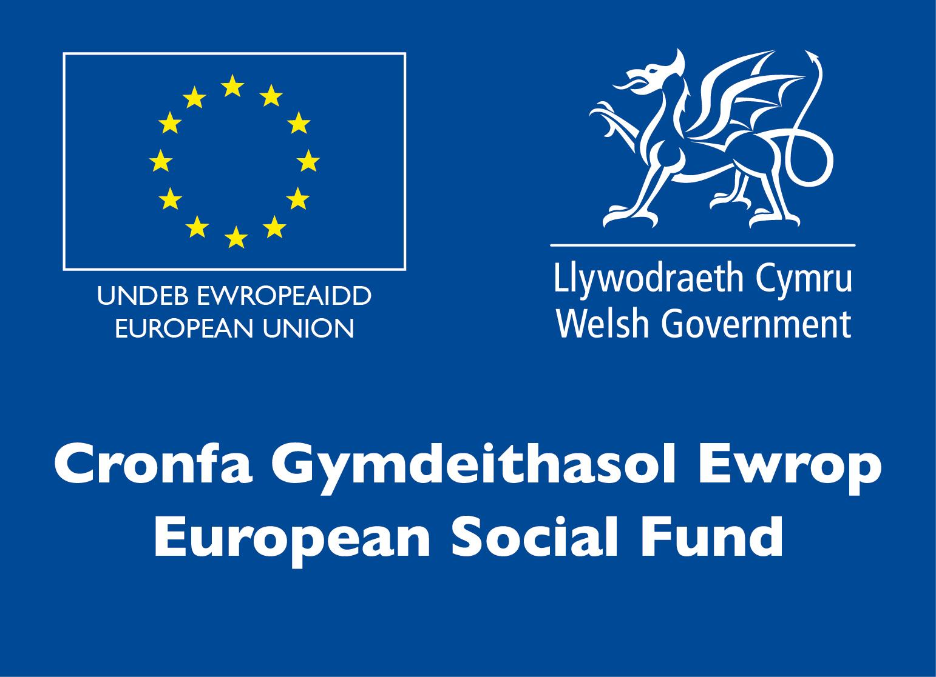• Application of instrumental and electroanalytical methods such as Spectrophotometry, Chromatography, Potentiometry and Conductometry.

• Logging, graphic evaluation and interpretation of the results of work and their documentation by using IT and statistical methods.

• Performance of work taking into consideration relevant norms as well as quality, safety and environmental standards.

• Appropriate written and oral command of language and specialist terminology as well as use of job-related foreign languages.

This competition takes 2.5 hours (including Health & Safety brief and report writing).

**Entry Criteria**

The competition is for those training for a career in Laboratory Science/Chemistry, and studying toward a Level 3 qualification, or relevant HE Degree (e.g. BSc Chemistry).

## Please ensure your entrants have the skills and competencies to complete the task.

## 

## Entry capacity restrictions by organisation

Maximum of up to 3 per organisation.

This is the maximum number of entries permitted by an organisation for this competition.

This is determined by ‘location’ and ‘organisation’. ‘Organisation’ refers to the competitors’ training provider/employer. ‘Location’ refers to a site where the competitor studies / is employed. For further guidance on these capacities, click [here](https://www.skillscompetitionwales.ac.uk/terms/entry-capacity-restrictions-by-organisation)

**Brief**

This competition consists of a simulation of a laboratory practical task that will be issued on the day. Competitors will be provided with instructions for the simulation.

Competitors are expected to risk assess the activity and communicate this in a word processed report. Data analysis and reporting on results also forms part of the assessment.

**Infrastructure List**

You will require a computer with internet access to use the simulation and engage in the online post competition workshops. Your report will need to be word processed in Microsoft Word, and you should have Microsoft Excel for analysis of data

You may also wish to have the following:

• A scientific calculator (not mobile phone app, no formulae etc. on the cover).

• Your own stationary.

Competitors will not be permitted to use the following during the competition:

• Mobile phones

**Competition Rules**

For full terms and conditions of entry and competition rules visit [www.skillscompetitionwales.ac.uk/terms-and-conditions](http://www.skillscompetitionwales.ac.uk/terms-and-conditions)

**Generic competition rules:**

• Mobile phones are to be switched off during competition activity. .

• Any questions during competition activity should be addressed to the competition judging panel.

• Competitors should not communicate with other competitors during competition activity.

• It is the responsibility of each competitor to arrive on time for each competition session. No additional time will be allowed if you arrive late.

• Failure of your equipment should be reported immediately to the judging panel. Additional time will be allocated if the fault is beyond the control of the competitor.

**Marking and Assessment**

Marking and judging of this competition will be done by a team of experts from Industry, Higher / Further Education or Training Provider, using a marking criteria and allocated marks to ensure consistency.

**Brief breakdown of marking and assessment**

All marks are objective and will be awarded by the judges on the following areas of your report.

|  |  |
| --- | --- |
| Work organisation and management | 10% |
| Communication and interpersonal skills | 10% |
| Techniques, procedures and methods | 35% |
| Data processing and record keeping | 15% |
| Analysis , interpretation and evaluation | 10% |
| Problem solving through scientific methods | 10% |
| Trends in applied science | 10% |
| Total | 100% |

**Feedback and Recognition**

Individual and Group verbal feedback will be provided at the end of the competition.

No results or awards will be awarded on the day, as marking will be quality assured.

Certificates of Participation will be issued on the day.

Medallists will be invited to a Celebration Event which will be held in March 2021, where the First, Second and Third Awards will be presented.

Marksheets will be made available to unsuccessful competitors after the quality assurance process has been completed. Further details will be provided to all competitors upon notification of outcomes.

**Competition Lead**

**Lead Contact and Expert Contact**

Dr Amy Herbert

amy.herbert@gowercollegeswansea.ac.uk

**Briff y Gystadleuaeth**

**Teitl y Gystadleuaeth**

Technegydd Labordai

**Trosolwg y Gystadleuaeth**

Mae gan Dechnegwyr Labordai sgiliau arbenigol sy'n caniatáu iddynt weithio mewn ystod eang o sefydliadau, gan gynnwys diwydiannau cemegol, biofeddygol, fferyllol, biotechnoleg a diwydiannau eraill mewn sefydliadau addysgol. Maent yn gallu gweithio o fewn tîm labordy ond hefyd yn unigol, gan gymryd cyfrifoldeb am ansawdd a chywirdeb y gwaith a wneir.

Yn y gystadleuaeth, bydd cystadleuwyr yn cael eu hasesu ar sgiliau a galluoedd technegwyr sy’n mynd i faes technoleg labordy mewn gwyddoniaeth. Disgwylir iddynt gael set graidd o sgiliau a galluoedd technegol yr hoffent eu dangos mewn amgylchedd cystadleuol a'u datblygu ymhellach drwy gystadleuaeth.

Dylai cystadleuwyr sy'n cymryd rhan yn y gystadleuaeth hon ddangos eu galluoedd yn:

• Darllen a chymhwyso dogfennau technegol megis cyfarwyddiadau sy'n ymwneud â dadansoddi neu weithdrefnau, fformiwleiddio a manylebau sylweddau, diagramau a llawlyfrau ar gyfer offer.

• Trin y dyfeisiau labordy, y cyfarpar a'r offer sydd i'w defnyddio, gan ymdrin hefyd â'r cemegau a ddefnyddir mewn labordai drwy weithredu taflenni data diogelwch a'r mesurau a gweithdrefnau sydd i'w deillio ohonynt.

• Paratoi a phrosesu samplau yn ogystal â phrosesau gwahanu ar gyfer cymysgeddau o hylifau a solidau.

• Perfformiad prosesau glanhau a chanolbwyntio megis canoli, distyllu, echdynnu, anweddu a chrisialu.

• Penderfynu ar baramedrau ffisegol a chysonion mater fel tymheredd, dwysedd, gwerth pH, mynegai atblygiad, pwynt toddi a dargludedd.

• Cymhwyso dulliau titrimetrig a disgyrchiant.

• Cymhwyso dulliau offerynnol ac electrodadansoddol fel Sbectroffotometreg, Cromatograffeg, Potentiometreg a Dargludedd.

• Logio, gwerthuso graffig a dehongli canlyniadau'r gwaith a'u dogfennaeth drwy ddefnyddio TG a dulliau ystadegol.

• Perfformiad gwaith gan ystyried normau perthnasol yn ogystal â safonau ansawdd, diogelwch ac amgylcheddol.

• Meistrolaeth ysgrifenedig a llafar priodol ar iaith a therminoleg arbenigol ynghyd â defnyddio ieithoedd tramor sy'n gysylltiedig â swydd.

Mae'r gystadleuaeth hon yn cymryd 2.5 awr (gan gynnwys Iechyd & Briff diogelwch ac ysgrifennu adroddiadau).

**Meini Prawf Mynediad**

Mae'r gystadleuaeth hon ar gyfer y rhai sy'n hyfforddi ar gyfer gyrfa mewn Gwyddoniaeth Labordai/Cemeg, ac sy’n astudio tuag at gymhwyster Lefel 3, neu Radd AU berthnasol (e.e. Cemeg BSc).

## 

## Sicrhewch fod gan eich ymgeiswyr y sgiliau a'r cymwyseddau i gyflawni'r dasg a ddarperir.

## 

## Cyfyngiadau capasiti mynediad fesul sefydliad

Uchafswm o 3 ymgeisydd fesul sefydliad.

Dyma uchafswm nifer yr ymgeiswyr a ganiateir gan sefydliad ar gyfer y gystadleuaeth hon.

Pennir hyn gan 'leoliad' a 'sefydliad'. Mae 'sefydliad' yn cyfeirio at ddarparwr/cyflogwr hyfforddiant y cystadleuwyr. Mae 'lleoliad' yn cyfeirio at safle lle mae'r cystadleuydd yn astudio / yn cael ei gyflogi. I gael rhagor o arweiniad ar y capasiti hyn, cliciwch yma

**Briff**

Mae'r gystadleuaeth hon yn cynnwys efelychu tasg ymarferol labordy a fydd yn cael ei chyhoeddi ar y diwrnod. Bydd cystadleuwyr yn cael cyfarwyddiadau ar gyfer yr efelychiad.

Disgwylir i gystadleuwyr asesu perygl y gweithgaredd a chyfleu hyn mewn adroddiad mewn prosesydd geiriau. Mae dadansoddi data ac adrodd ar ganlyniadau hefyd yn rhan o'r asesiad.

**Rhestr Seilwaith**

Bydd angen cyfrifiadur gyda mynediad i'r rhyngrwyd i ddefnyddio'r efelychiad a chymryd rhan yn y gweithdai ôl-gystadleuaeth ar-lein. Bydd angen prosesu geiriau eich adroddiad yn Microsoft Word, a dylech gael Microsoft Excel ar gyfer dadansoddi data.

Efallai yr hoffech hefyd gael y canlynol:

• Cyfrifiannell gwyddonol (nid ap ffôn symudol, dim fformiwlâu ac ati ar y clawr).

• Eich offer eich hun.

Ni chaniateir i gystadleuwyr ddefnyddio'r canlynol yn ystod y gystadleuaeth:

* Ffôn Symudol

**Rheolau Cystadlu**

Am delerau ac amodau llawn rheolau mynediad a chystadleuaeth ewch i http://www.skillscompetitionwales.ac.uk/terms-and-conditions

**Rheolau cystadleuaeth gyffredinol**

* Dylid cyfeirio unrhyw gwestiynau yn ystod gweithgaredd cystadlu at banel beirniaid y gystadleuaeth.
* Ni ddylai cystadleuwyr gyfathrebu â chystadleuwyr eraill yn ystod y gystadleuaeth.
* Cyfrifoldeb pob cystadleuydd yw cyrraedd mewn pryd ar gyfer pob sesiwn gystadlu. Ni chaniateir unrhyw amser ychwanegol os byddwch chi'n cyrraedd yn hwyr.
* Pe bai unrhyw nam technegol ar eich offer, dylid rhoi gwybod i’r panel beirniaid yn syth. Dyrennir amser ychwanegol os yw'r nam y tu hwnt i reolaeth y cystadleuydd.

**Marcio ac Asesu**

Bydd marcio a beirniadu'r gystadleuaeth hon yn cael ei wneud gan dîm o arbenigwyr o’r diwydiant, darparwyr addysg bellach/uwch neu hyfforddiant, gan ddefnyddio meini prawf marcio a marciau a ddyrannwyd i sicrhau cysondeb.

**Dadansoddiad o'r marcio a'r asesu**

Mae pob marc yn wrthrychol a chânt eu dyfarnu gan y beirniaid fel a ganlyn

|  |  |
| --- | --- |
| Trefniadaeth a rheolaeth waith | 10% |
| Sgiliau cyfathrebu a rhyngbersonol | 10% |
| Technegau, gweithdrefnau a dulliau | 35% |
| Prosesu data a chadw cofnodion | 15% |
| Dadansoddi, dehongli a gwerthuso | 10% |
| Datrys problemau drwy ddulliau gwyddonol | 10% |
| Tueddiadau mewn gwyddoniaeth gymhwysol | 10% |
| Cyfanswm | 100% |

**Adborth a Chydnabyddiaeth**

Darperir adborth llafar i unigolion a grwpiau ar ddiwedd y gystadleuaeth.

Ni ddyfernir unrhyw ganlyniadau na dyfarniadau ar y diwrnod gan y bydd angen sicrhau ansawdd y marcio.

Cyflwynir Tystysgrifau Cyfranogi ar y diwrnod.

Gwahoddir enillwyr y medalau i Ddigwyddiad Dathlu a gynhelir ym mis Mawrth 2021, ble bydd y Wobr Gyntaf, Ail a Thrydedd yn cael eu cyflwyno.

Bydd taflenni marcio ar gael i gystadleuwyr aflwyddiannus ar ôl i'r broses sicrhau ansawdd gael ei chwblhau. Rhoddir rhagor o fanylion i bob cystadleuydd pan fyddant yn cael gwybod am ganlyniadau.

**Arweinydd y Gystadleuaeth**

**Cyswllt Arweiniol a Chyswllt Arbenigol**

Dr Amy Herbert

amy.herbert@gowercollegeswansea.ac.uk