**Competition Brief**

**Competition Title**

Vehicle Body Repair

**Competition Overview**

Vehicle Body Repair Technicians specialise in repairing or replacing accident damaged panels on all types of vehicles. They use a variety of specialised tools and equipment to repair damage and return the vehicle to a safe condition.

In this competition, competitors will be assessed on their skills, knowledge and abilities against current industry standards and working practices. They will need to demonstrate good time management, problem solving and planning skills, as well as prove their ability to collect and analyse information and apply logical techniques to solve problems.

**Entry Criteria**

This competition is for those training for a career in the Automotive Industry and studying towards a Level 2 - 3 qualification or apprenticeship.

Please ensure your entrants have the skills and competencies to complete the task.

**Entry capacity restrictions by organisation**

Maximum of up to 4 per organisation.

This is the maximum number of entries permitted by an organisation for this competition.

This is determined by ‘location’ and ‘organisation’. ‘Organisation’ refers to the competitors’ training provider/employer. ‘Location’ refers to a site where the competitor studies / is employed. For further guidance on these capacities, click [here](https://www.skillscompetitionwales.ac.uk/terms/entry-capacity-restrictions-by-organisation)

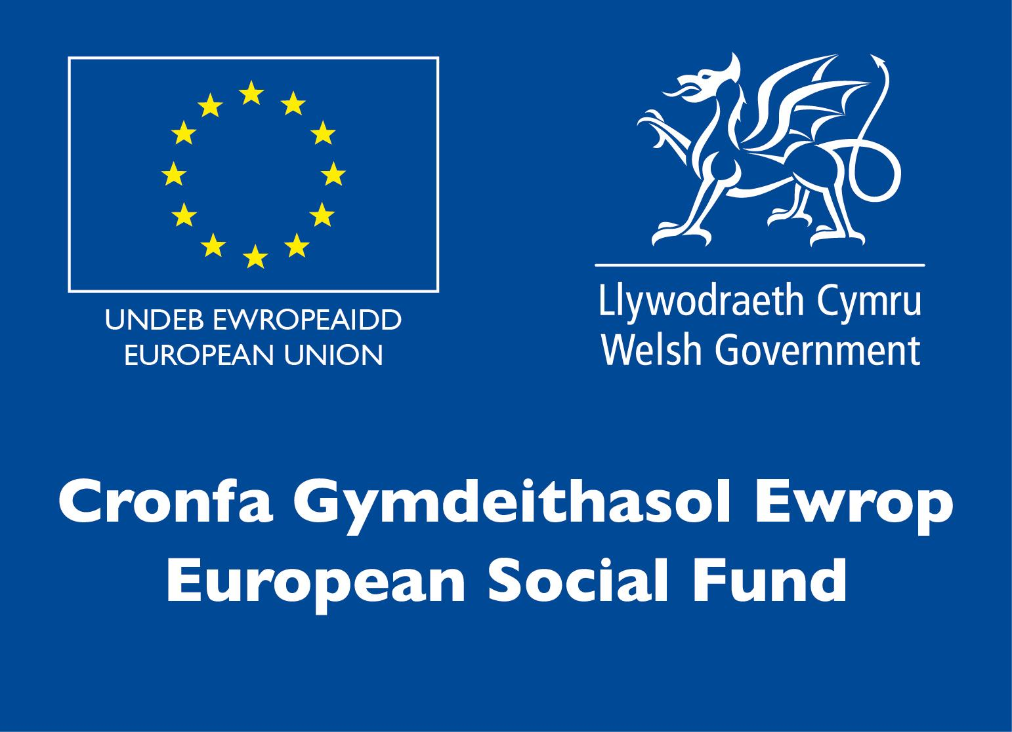**Brief**

The Competition consists of four practical tasks in the areas below:

● MIG Welding

● Spot Welding

● Filler Work

● Metal Finishing

Due to the current restrictions in place, the competition will be hosted at your place of study/organisation. The resources for the tasks will be delivered to your college prior to the competition; they will then be collected to be marked centrally.

Each task is between 30 minutes - 1 hour and will be timetabled through the day. There will usually be down time in between tasks for refreshments.

For further information please refer to the Skills Competition Wales website.

**Infrastructure List**

All Equipment needed to complete the task will be available at the competition venue.

**Competition Rules**

For full terms and conditions of entry and competition rules visit [www.skillscompetitionwales.ac.uk/terms-and-conditions](http://www.skillscompetitionwales.ac.uk/terms-and-conditions)

**Competition specific rules**

The competitor who is awarded 1st overall will automatically gain a place in the UK regional without having to do the online test. Please note that this is for automotive competitions only.

**Generic competition rules**

• Mobile phones are to be switched off during competition activity.

• Listening to music via headphones is not permitted during competition activity.

• Any questions during competition activity should be addressed to the competition judging panel.

• Competitors should not communicate with other competitors during competition activity.

• It is the responsibility of each competitor to arrive on time for each competition session. No additional time will be allowed if you arrive late.

• Technical failure of your equipment should be reported immediately to the judging panel. Additional time will be allocated if the fault is beyond the control of the competitor.

**Marking and Assessment**

Marking and judging of this competition will be done by a team of experts from Industry, Further Education or Training Provider, using a marking criteria and allocated marks to ensure consistency.

Brief breakdown of marking and assessment.

|  |  |  |
| --- | --- | --- |
| A | Health & Safety | 10% |
| B | Interpreting Manufacturers Data | 10% |
| C | Correct Completion of Task | 70% |
| D | Knowledge Questions | 10% |
|  | Total | 100% |

**Feedback and Recognition**

Individual and Group verbal feedback will be provided at the end of the competition.

No results or awards will be awarded on the day, as marking will be quality assured.

Certificates of Participation will be issued on the day.

Medallists will be invited to a Celebration Event which will be held in March 2021, where the First, Second and Third Awards will be presented.

Marksheets will be made available to unsuccessful competitors after the quality assurance process has been completed. Further details will be provided to all competitors upon notification of outcomes.

**Competition Lead**

**Lead Contact**

Robert Morse

[Robert.morse@coleggwent.ac.uk](mailto:Robert.morse@coleggwent.ac.uk)

**Expert Contacts**

Robert Morse

[Robert.morse@coleggwent.ac.uk](mailto:Robert.morse@coleggwent.ac.uk)

**Briff y Gystadleuaeth**

**Teitl y Gystadleuaeth**

Atgyweirio Cyrff Cerbydau

**Trosolwg o'r gystadleuaeth**

Mae Technegwyr sy’n Atgyweirio Cyrff cerbydau yn arbenigo mewn atgyweirio neu newid paneli sydd wedi eu difrodi mewn damweiniau ar bob math o gerbyd. Maen nhw’n defnyddio amrywiaeth o offer arbenigol i drwsio difrod ac yn dychwelyd y cerbyd mewn cyflwr diogel.

Yn y gystadleuaeth hon, caiff cystadleuwyr eu hasesu ar eu sgiliau, gwybodaeth a’u gallu yn erbyn safonau ac arferion gwaith diwydiannol cyfredol. Bydd angen iddyn nhw arddangos eu bod yn gallu rheoli eu hamser yn dda, bod ganddyn nhw sgiliau datrys problemau a chynllunio da yn ogystal â phrofi eu gallu i gasglu a dadansoddi gwybodaeth a defnyddio technegau rhesymegol i ddatrys problemau.

**Meini Prawf**

Mae’r gystadleuaeth hon ar gyfer y rhai hynny sy’n hyfforddi am yrfa yn y Diwydiant Cerbydau ac yn astudio tuag at gymhywster Lefel 2-3 neu brentisiaeth.

Sicrhewch fod gan eich ymgeiswyr y sgiliau a’r gallu i gyflawni’r dasg.

**Cyfyngiadau ymgeisio gan sefydliad**

Cyfanswm o hyd at 4 i bob lleoliad.

Dyma’r mwyafswm o gystadleuwyr a ganiateir gan sefydliad ar gyfer y gystadleuaeth hon.

Caiff hyn ei benderfynu ar sail ‘lleoliad’ a ‘sefydliad’. Mae ‘sefydliad’ yn cyfeirio at ddarparwr hyfforddiant/cyflogwr y cystadleuwyr. Mae ‘lleoliad’ yn cyfeirio at y safle lle mae’r cystadleuydd yn astudio/cael ei gyflogi. Am ragor o arweiniad ar y canllawiau hyn, cliciwch yma

**Briff**

Mae’r Gystadleuaeth yn cynnwys pedair tasg ymarferol yn y meysydd isod:

● Weldio MIG

● Sbot-weldio

● Gwaith llenwi

● Rhoi Gorffeniad ar Fetel

Oherwydd y cyfyngiadau cyfredol sydd ar waith, cynhelir y gystadleuaeth yn eich man astudio / sefydliad. Bydd yr adnoddau ar gyfer y tasgau yn cael eu cyflwyno i'ch coleg cyn y gystadleuaeth; yna cânt eu casglu i gael eu marcio'n ganolog.

Mae pob tasg rhwng 30 munud ac 1 awr o hyd a bydd amserlen ar eu cyfer drwy’r dydd; fel arfer bydd amser rhydd rhwng pob tasg er mwyn cael bwyd a diod.

Am ragor o wybodaeth ewch i wefan Cystadleuaeth Sgiliau Cymru.

**Rhestr Seilwaith**

Bydd yr holl offer sydd ei angen i gyflawni’r dasg gar gael yn lleoliad y gystadleuaeth.

**Rheolau’r Gystadleuaeth**

I weld y telerau ac amodau cystadlu a rheolau’r gystadleuaeth ewch i: www.skillscompetitionwales.ac.uk/terms-and-conditions

**Rheolau Penodol ar gyfer y Gystadleuaeth hon**

Bydd y cystadleuydd buddugol yn ennill lle yn rownd ranbarthol y DU heb orfod gwneud prawf ar-lein. Sylwch bod hwn ar gyfer cystadleuwyr cerbydol yn unig.

**Rheolau cyffredinol**

• Rhaid diffodd ffonau symudol yn ystod y gystadleuaeth ei hun.

• Ni chaniateir gwrando ar gerddoriaeth drwy glustffonau yn ystod y gystadleuaeth ei hun.

• Dylid cyfeirio unrhyw gwestiynau yn ystod gweithgaredd y gystadleuaeth i banel beirniadu’r gystadleuaeth.

• Ni ddylai cystadleuwyr gyfathrebu gyda chystadleuwyr eraill yn ystod y gystadleuaeth ei hun.

• Cyfrifoldeb pob cystadleuydd yw cyrraedd ar amser ar gyfer pob sesiwn gystadlu. Ni chaniateir rhagor o amser os byddwch yn cyrraedd yn hwyr.

• Dylid adrodd am unrhyw fethiant technegol yn eich offer ar unwaith i’r panel beirniadu. Caiff y cystadleuydd amser ychwanegol os yw’r nam y tu hwnt i’w reolaeth.

**Marcio ac Asesu**

Bydd tîm o arbenigwyr yn y byd Diwydiant, Addysg Bellach neu Ddarparwr Hyfforddiant yn marcio a beirniadu’r gystadleuaeth hon a byddant yn defnyddio meini prawf marcio a marciau sydd wedi eu pennu er mwyn sicrhau cysondeb.

Dadansoddiad cryno o’r marcio ac asesu.

|  |  |  |
| --- | --- | --- |
| A | Iechyd a Diogelwch | 10% |
| B | Dehongli Data Gwneuthurwyr | 10% |
| C | Cwblhau Tasg yn Gywir | 70% |
| Ch | Cwestiynau Gwybodaeth | 10% |
|  | Cyfanswm | 100% |

**Adborth a Chydnabyddiaeth**

Bydd adborth ar lafar yn cael ei roi i Unigolion a Grwpiau ar ddiwedd y gystadleuaeth.

Ni chaiff unrhyw ganlyniadau na dyfarniadau eu cyflwyno ar y diwrnod gan y byddwn yn marcio drwy sicrhau ansawdd.

Caiff Tystysgrifau Cyfranogi eu cyflwyno ar y dydd.

Bydd enillwyr yn cael eu gwahodd i Ddigwyddiad Dathlu a gaiff ei gynnal yn mis Mawrth 2021, lle caiff y Gwobrau ar gyfer y Cyntaf, Ail a Thrydydd eu cyflwyno.

Bydd taflenni marcio ar gael i gystadleuwyr aflwyddiannus ar ôl i’r broses sicrhau ansawdd gael ei chwblhau. Caiff manylion pellach eu darparu i bob cystadleuydd ar ôl iddynt gael gwybod beth yw’r canlyniadau.

**Arweinydd y Gystadleuaeth**

**Prif Gyswllt**:

John Sexton

[John.Sexton@coleggwent.ac.uk](mailto:John.Sexton@coleggwent.ac.uk)

Matt Collins

[matthew.collins@coleggwent.ac.uk](mailto:matthew.collins@coleggwent.ac.uk)